Analyzing with Rows AI
Rows (rows.com) is a modern, AI-powered spreadsheet platform designed as an intelligent data analysis tool. It combines the familiar grid interface of traditional spreadsheets like Excel or Google Sheets with powerful AI capabilities to help users import, clean, transform, analyze, and visualize data much faster — often using plain English prompts instead of complex formulas, SQL, or manual coding. The core feature lets you chat with your data in natural language. Rows positions itself as a no-code AI data analyst that bridges the gap between simple spreadsheets and full business intelligence tools. It is particularly strong for teams handling marketing, sales, finance, or operational data who want quick insights without deep technical skills.
Prompting: Unlike most other AI where prompting can be difficult, Rows AI prompting is simply asking what you want out of it. It’s important to understand what kind of information you want out of the data. Asking precisely what you are asking for. An example could be to find “total inventory breakdown” or “prepare a pie chart for expenses” that will show which expense type have we spent the most money on. It can also be used for filtering data and the prompting would look like, “Show me every kind of packaging expense from the expense account”.
Output
I used a sample data set from a small venture I worked on. It outlined the data input of the expenses incurred during operations. The data was imported from google sheets and three queries were asked.
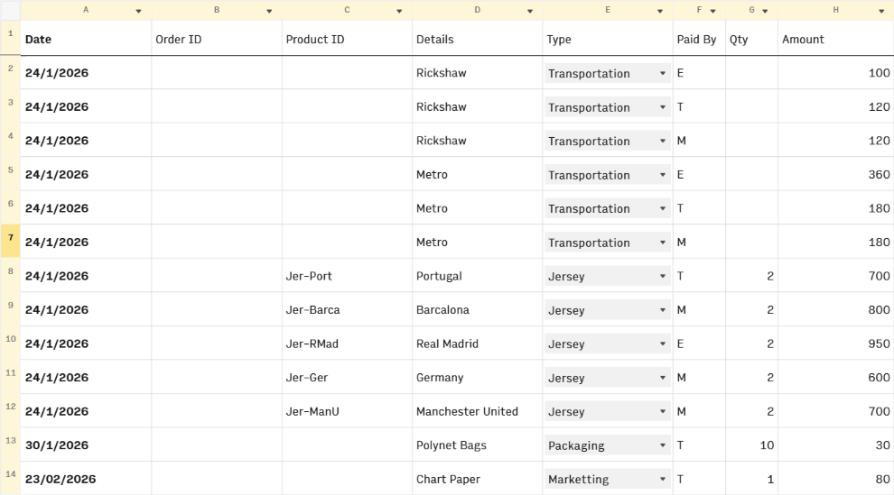
These were some of the outputs I asked using Rows AI asking about account balances if the capital invested was 5000 BDT each. The breakdown of the types of expenses and their amount.
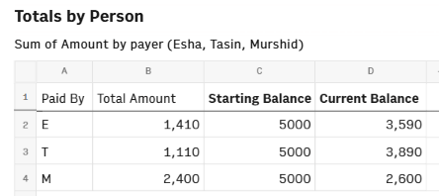
It was also asked to summarize key data points to take away from the entries. In one querry it was asked to find inventory breakdowns, total expenses paid by each individual and the total amount of expenses paid.
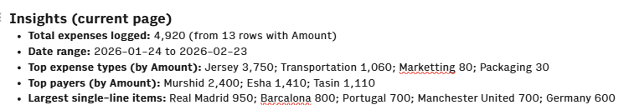
Prompt Structure
“Find + desired output + criteria”
This is one of the easiest ways to learn how to use Rows to find your desired output. To create charts or graphs a basic structure could be to use the following.
“Prepare a chart/graph + criteria + output”
The last advice to give when writing a prompt for Rows AI is to ask exactly what you want. Be detailed because it has a hard time understanding vague instructions. Let’s say you want to find the total amount of money someone has spent using this example. Rather than saying “Provide me information on how much each individual has spent”, this would just give you a detailed breakdown of individual expenses. Instead type, “Create pivot table for who paid what amount and give me totals for all three people”.
Conclusion
To summarize, Rows AI could be the next generation of data analytics. Rather than spending countless hours learning functions of excel or maintaining large databases with SQL, Rows AI can help prepare reports, keep track of changes and compute multiple functions that would only take a fraction of the time it takes to prepare using excel or any other database tool. It also has a small learning curve. However, just because you don’t have to know how to do said functions it’s important to understand what kind of functions are available to use and knowing to ask for the right functions for the kinds of output is very crucial whilst using a tool like Rows AI.

